



Data Structures & Algorithm
LAB MANUAL

Disclaimer: The content is curated from online/offline resources and used for educational purpose only
Insert Element into Linked List

Objective:
To learn node insertion techniques in different positions.
Equipment Required:
- Computer with Python installed, text editor/IDE.

Prerequisites:
Basic knowledge of classes and object-oriented programming.
Problem Statement:
Write a program to insert nodes at the beginning, middle, and end of a singly linked list.

Procedure:
- Create methods to insert at the beginning, middle, and end.
- Use the Node class to add elements accordingly.
- Display the updated list.

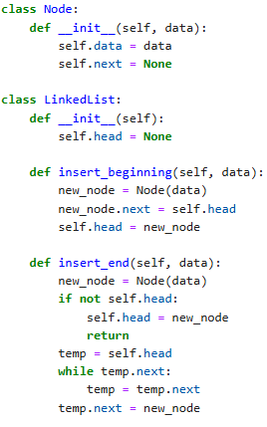
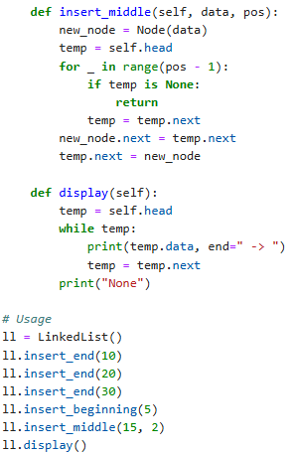

Output:

Output:

